**Easy Apply**

**Mahmoud Anabusi, Mohammed Raddad & Moath Sweidan**

**Axsos Academy**

**Palestine**

* **About:**

Our website basic idea about making it easy for both the job seekers & the job owner for find each other’s quickly and accurately, now adays as the technology grows up daily and evolves our needs also, so we came to you with a website which receives the request from both parties (unemployed & employer) to match between and gain the benefit for both.

The project called Easy Apply, which basically contains from 9 pages (Home, registration for the unemployed, registration for the employer (we will make it for the admin only), the admin page, job vacancies presenting (the unemployed side), Job opportunities creating and presenting, CV creating, CV review, submit review & unemployed approval process (matches the candidates with the vacancies).

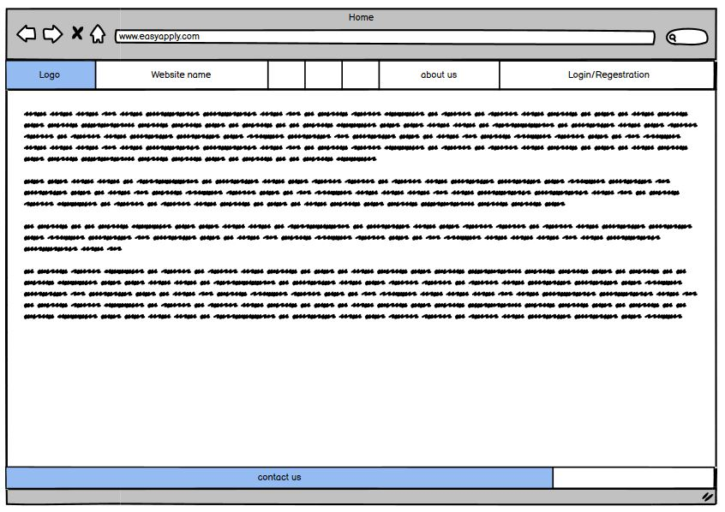

The routes and the pages functions for the described project will be as bellow:

* **Home Page (EasyApply):**

This is the first page will appear to our site visitors, which will contain three parts:

1. The navbar: contains our logo, name, about us description & registration / log in button.
2. Text field with the welcome letter.
3. The footer: contains the contact details and other useful links such as FAQ.

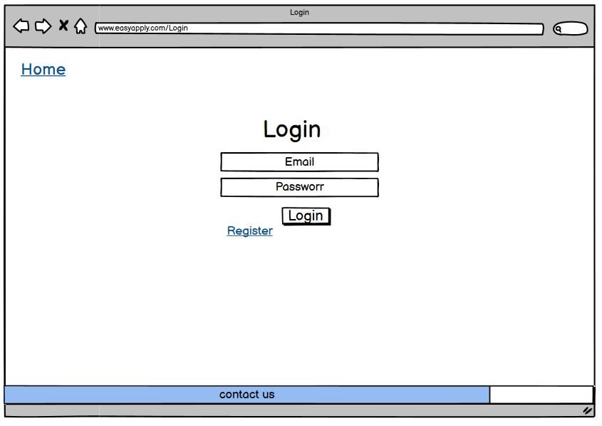

* **Login & Registration (EasyApply/Login or Register):**

This page will enable us for login to the user account if he is already registered in the site before or to register if he is new user. It will contain filling for some of the personal information for the user such as first & last name, email & birthday.

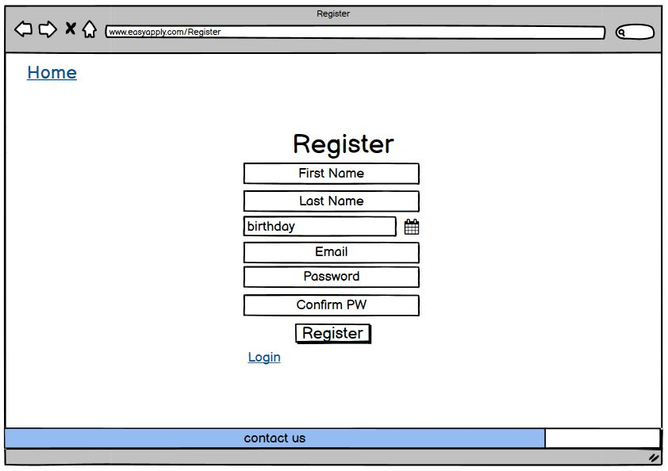

* **Welcome (EasyApply/user/id)):**

This page to preview the user information and to show all the available vacancies which he can apply, also it allows the user to create his CV to filter the vacancies as per the user specialty & finally to track his application/s.

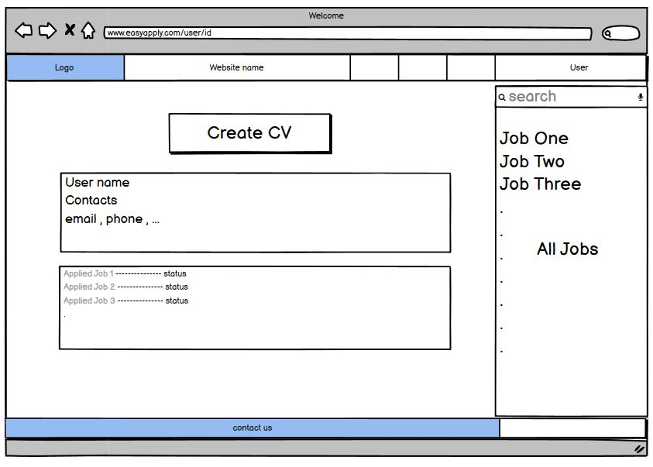

* **The Admin Page (registration for the employer) (EasyApply/Admin):**

This is the admin page, which will allow us to add the open vacancies to advertise on the web page and include it under the specialties to filter them.

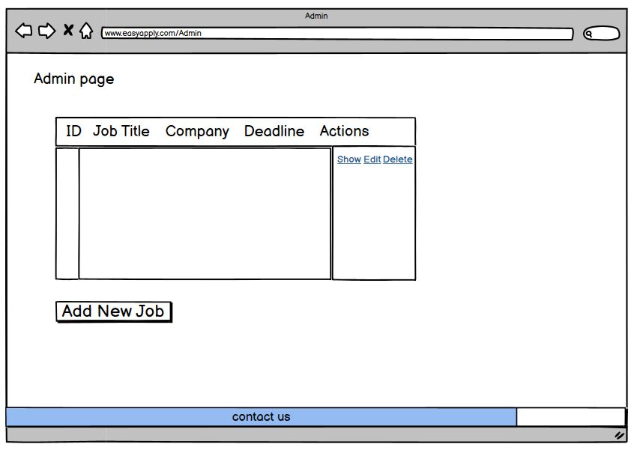

* **The Admin Page (for action) (EasyApply/Admin/add_Job):**

This page allows the admin to review, edit & delete the closed vacancies.

* **CV Builder (EasyApply/user/id/createCV):**

The user will go through this page to fill up the required information to build his final CV and to allow him for submissions, it will include the basic information which already we used for register and will include the education field, trainings, experiences, etc.

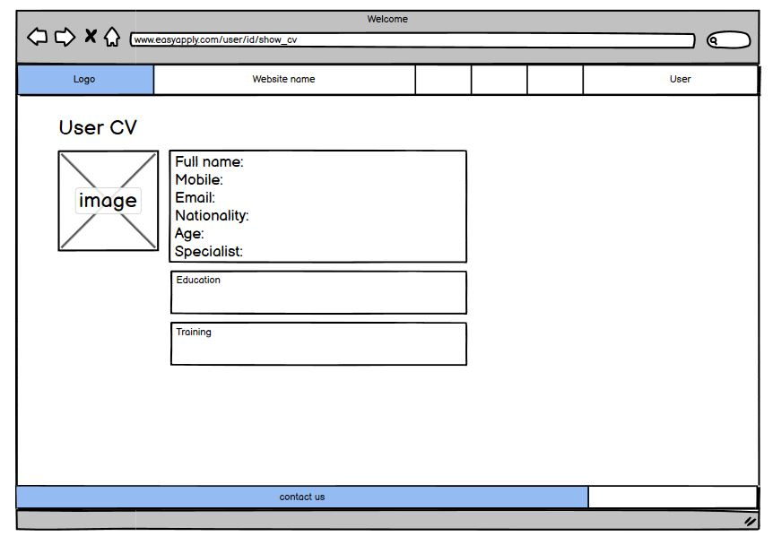

* **CV Preview (EasyApply/user/id/CV):**

This page will display the CV in final view for submitting, review, edit & print it.

* **Job Show (EasyApply/user/id/JobShow):**

The user will be directed to this page which allows him to view the wished vacancy, and if it is still active, then he can apply for it.

**The Project Requirements:**

1. **Home Page (localhost/8000):**
   * This page is responsive.
   * Includes NavBar:
     + Logo: no action.
     + About Us: drop down text.
     + Login: link which route for login page. (localhost/8000/login)
     + Register: link which route for register page. (localhost/8000/register)
   * Welcome text & summary. (Paragraph introduction will be about the project and the mechanism for job applies).
   * Footer contains (contacts). (Link to route us for the social account of the company (not active))
2. **Login Page:** **(localhost/8000/login)**
   * This page is responsive.
   * Validation for email to make sure the user is registered.
   * Validation for password as correct password.
3. **Admin Page: (localhost/8000/admin)**
   * This page displays a table contains a list for all vacancies available on the website with links routes for the actions which will be taken by the admin.
   * Create new vacancy: this is the first action which allows the admin to create new job, the information which will be filled is the vacancy title, description, expiry date & button (add new vacancy) to create the vacancy.
   * Edit the vacancy: this is the second action, which allows the admin to update the selected vacancy and it is not a new directed page, it is the same as create a new vacancy page.
   * Delete the vacancy: this is the third action, and it is a link in the displayed table which will delete the vacancy direct.
4. **Admin Page Action: (localhost/8000/admin/addJob)**
   * This page will display text field (as title for the vacancy).
   * Text field have the job description.
   * Drop down list to choose the specialty to filter the vacancies on the user page which is have the same specialty.
   * Date field for vacancy expiry date.
   * Add job button: which will post the job.
   * Update the job button: which will recall the advertised job and display it on the same page to edit it (localhost/8000/admin/addJob).
   * Back button to return to the admin page. (localhost/8000/admin).
5. **Register Page (user): (localhost/8000/Register)**
   * This page basic register page contains text field for first name which must have only letters without number or special characters and should be at least 3 characters.
   * text field for last name which must have only letter without number or special characters and should be at least 3 characters.
   * Birthday tab: validate that the user is above 21 years old.
   * Email field: must be regex and unique.
   * Password field: hashed & encrypted and at least 8 characters.
   * Confirm password field: match the password field.
   * Register button: for registration and will redirect the user to the welcome page (loclahost8000/user/id)).
   * Home link to redirect the user to the home page (localhost/8000).
   * Login link to redirect the user to the login page if the user already registered (localhost/8000/login)
6. **Welcome Page (user): (EasyApply/user/id))**
   * This page will be redirected after user registration or logging in.
   * Display a button called create CV which will redirect the user to CV builder page (localhost/8000/user/id/editCV).
   * Information field have the basic information first name, last name, birthdate & email.
   * Information field have the tracker for the applied vacancies as a links which will redirect the user to job show page (localhost/8000/user/id/JobShow)
   * Side bar field have all the vacancies announced on the website for all the specialties (if the user did not create his CV yet), if the user created his CV the side bar will display all the related vacancies only.
   * Logout button for logout and after logout will redirect to the homepage (localhost/8000).
7. **CV Builder Page: (localhost/8000/user/id/createCV):**
   * The user will be directed to this page after pressing the button (create your CV) in user welcome page.
   * It contains (personal photo) image field which will be uploaded by the user.
   * Personal information field contains:
     + First name, last name, birthdate, email which will be called back from the registration process.
     + Phone number field: must contains only numbers and must be 10 numbers.
     + Nationality field: text field contains letter characters without numbers & special characters and not less than 3 characters.
     + Specialty text field: contains drop list to choose the specialty of the user.
     + Education text field: contains minimum 20 characters.
     + Training text field: contains minimum 20 characters.
     + Work Experience text field: contains minimum 20 characters.
   * Save button: to save the information and redirect us to the CV show page (localhost/8000/user/id/showCV).
8. **CV Show Page: (localhost/8000/user/id/showCV)**
   * This page will display the CV after filling the information as above captioned, it will have three buttons:
   * Print button: to print the cv as hard copy.
   * Edit button: will redirect the page to (localhost/8000/user/id/createCV) to update the CV information.
   * Continue button: will redirect the page to user page (localhost/8000/user/id) then the side bar will display the available vacancies related to the user specialty.
   * Logout button: for logout and redirect the user to the homepage (localhost/8000).
9. **Job Show Page: (localhost/8000/user/id/job_show)**
   * This page will be redirected after the user press the displayed available vacancy (link) which appear on the side bar in the user page.
   * This page contains (Apply for this Position) button which will add the desired vacancy to the application list on the user page.

Optional:

* + Cancel button: which will cancel the vacancy application and redirect the page back to the user page (localhost/8000/user/id).